Streaming Revenue Driver Model Final Report v2
Standalone final documentation for the streaming media revenue model only
Prepared: April 1, 2026
Confidence score: 78 / 100

Table of Contents
Right-click and update field to generate the table of contents.

Executive Summary
This report documents the streaming media revenue driver model as a standalone forecasting framework. It shows how subscriber acquisition, segmented churn, voluntary and involuntary reactivation, ARPU methodology, billing leakage, pricing dynamics, and installed-base expansion interact inside one connected recurring-revenue system. The model was designed to defend the LinkedIn article thesis that revenue forecasting is most credible when the operating drivers are visible and connected.
The model uses a subscriber-weighted ARPU of approximately 9.60, derived from Netflix, Disney+, and Warner Bros. Discovery disclosure anchors. Billing leakage is explicitly scenario-based over a 2%-8% range with 4.5% as the base case. Churn is segmented by cohort type: new subscriber churn 4.5%, retained subscriber churn 3.8%, and reactivated subscriber churn 7.2%. Reactivation is split between voluntary and involuntary churn pools, with involuntary recovery returning more quickly. The final confidence score is 78/100.
Streaming CAC was excluded from the final framework because public-source support was not strong enough to estimate it at acceptable confidence. Exclusion was the more defensible choice.

LinkedIn Article Context
The LinkedIn article argues that forecasting should reveal the mechanisms that create revenue. In streaming, those mechanisms are subscriber acquisition, churn, reactivation, pricing, and monetization quality. A top-line-only revenue forecast hides too much of the business. The streaming model therefore defends the article by showing how subscriber states roll into recurring revenue, and how churn and reactivation materially change the path of MRR and ARR.

Model Overview and Architecture
The streaming model is a 24-month state-transition cohort system. It begins by deriving subscribers from rate-card MRR divided by subscriber-weighted ARPU. Each month, subscribers move across active-new, active-retained, and active-reactivated states. Each state carries a different churn rate. Churned subscribers are divided into voluntary and involuntary pools, each with its own reactivation curve. Pricing, tier migration, and promotional dilution affect ARPU, while installed-base expansion and contraction affect monetization beyond the subscriber count alone.
- Starting point: rate-card MRR of 12,026 and implied beginning subscribers from weighted ARPU
- Segmented churn by cohort type to avoid one-size-fits-all retention assumptions
- Separate voluntary and involuntary churn reactivation curves
- Billing leakage range disclosed and applied to convert rate-card MRR to effective MRR
- State-transition logic extended to 24 months to better represent multi-cycle reactivation

All Streaming KPIs
KPI | Documentation
Subscribers | Beginning and ending active subscribers by month.
Weighted ARPU | Subscriber-weighted average monetization anchor from disclosed operator data.
MRR | Rate-card MRR, effective MRR after leakage, and total MRR after installed-base expansion.
ARR | Annualized total MRR run rate.
New adds | Gross monthly subscriber additions from the acquisition engine.
Voluntary churn | Churn from cancel behavior or active opt-out.
Involuntary churn | Churn tied to billing failure or similar forced loss.
Reactivations | Return of prior churned subscribers under segmented curves.
Net churn | Gross churn after reactivation offsets.
Expansion | Installed-base monetization gains beyond subscriber count alone.
Contraction | Promotional or downgrade-style revenue dilution.
Billing leakage | Difference between rate-card and effective collected recurring revenue.

Data Sources and Methodology
The streaming model uses operator disclosures and benchmark research as its primary evidence base. Netflix, Disney+, and WBD anchor subscriber scale and ARPU. Antenna informs voluntary reactivation. Recurly informs billing leakage and involuntary recovery context. Churnkey provides public-range support for streaming churn assumptions. The model therefore uses a defensible triangulation approach rather than forcing one source to explain all behavior.
Source | Metric Used | URL | Why Used
Netflix | Q4 2024 subscribers 301.63M; 2024 global ARM $11.70 | https://ir.netflix.net/financials/annual-reports-and-proxies/default.aspx | Primary operator disclosure anchor for streaming scale and monetization
Disney+ | Q4 2024 subscribers 158.6M; overall ARPU $7.20 | https://www.sec.gov/Archives/edgar/data/1744489/000174448924000275/fy2024_q4xprxex991.htm | Primary operator disclosure anchor for subscriber scale and ARPU
Warner Bros. Discovery DTC | Q4 2024 subscribers 116.9M; DTC ARPU $7.44 | https://www.wbd.com/news/warner-bros-discovery-reports-fourth-quarter-and-full-year-2024-results | Primary operator disclosure anchor for DTC subscriber scale and ARPU
Antenna | Streaming reactivation / resubscription curves | https://www.antenna.live/insights/resubscription-is-on-the-rise | Primary benchmark for voluntary reactivation dynamics
Recurly | Billing leakage, involuntary churn recovery context | https://recurly.com/research/churn-rate-benchmarks/ | Primary benchmark for decline exposure and recovery-based leakage range
Churnkey | Streaming churn range context | https://churnkey.co/blog/churn-rates-for-streaming-services/ | Supplemental public benchmark for streaming churn bands

Subscriber-Weighted ARPU Methodology
The weighted ARPU is calculated as Σ(subscribers × ARPU) / Σ(subscribers). Using the disclosed Q4 2024 subscriber counts and ARPU/ARM anchors from Netflix, Disney+, and WBD produces a weighted ARPU of approximately 9.60. This is more defensible than a simple average because it gives greater influence to larger operators and therefore better reflects the subscriber mix represented by public market scale.
This correction directly addresses the audit concern that a simple average could distort monetization. In the final model, the simple average is shown only as a comparison point, not as the governing input.

Billing Leakage Scenarios
The model no longer hides billing leakage. Instead, it presents a low-base-high range of 2%, 4.5%, and 8%. The base case is aligned to decline exposure and recovery logic from public subscription-billing research. Effective MRR is calculated after leakage, making the difference between rate-card and collected revenue explicit.
Scenario | Billing Leakage % | Churn Multiplier | Pricing / Expansion Multiplier | Month24 Total MRR | Month24 ARR | Average Net Churn
Low | 0.0200 | 0.8500 | 0.8000 | 23,532.27 | 282,387.29 | 0.0210
Base | 0.0450 | 1 | 1 | 22,944.39 | 275,332.65 | 0.0247
High | 0.0800 | 1.15 | 1.20 | 22,116.84 | 265,402.03 | 0.0284

Segmented Churn and Reactivation
The model uses different churn assumptions for new, retained, and reactivated subscribers because the audit correctly identified that those cohorts should not behave identically. The base rates are 4.5% for active-new, 3.8% for active-retained, and 7.2% for active-reactivated subscribers. Voluntary churn and involuntary churn are then placed in separate return pools, with involuntary return assumed to happen faster than voluntary return.
This segmentation improves both realism and interpretability. It also makes reactivation dampening measurable: the model calculates how much of gross churn is offset by returning subscribers each month.

Tier Migration, Pricing Dynamics, and State Tracking
ARPU is dynamic over time. It evolves through baseline price growth, modest tier-migration uplift, and periodic promotional drag. State-transition tracking then determines how many subscribers are exposed to those monetization dynamics. Because the model keeps active-new, active-retained, and active-reactivated subscribers separate, the interaction between pricing and churn can be discussed in a much more structured way than in a flat revenue forecast.

Formulas and Calculations
Metric | Formula
Beginning subscribers | Rate-card MRR / weighted ARPU
Weighted ARPU | Σ(subscribers × ARPU) / Σ(subscribers)
Gross churn | Voluntary churn + involuntary churn
Total reactivations | Reactivated voluntary + reactivated involuntary + reactivated repeat
Net churn rate | max((Gross Churn − Total Reactivations) / Beginning Subscribers, 0)
Rate-card MRR | Ending subscribers × weighted ARPU
Effective MRR | Rate-card MRR × (1 − billing leakage)
Net expansion MRR | Gross expansion MRR − contraction MRR
Total MRR | Effective MRR + net expansion MRR
ARR run rate | Total MRR × 12

24-Month Forecast Results
At month 24, the streaming model reaches total MRR of 22,944.39 and ARR run rate of 275,332.68. Average net churn across the 24 months is 2.47%, while average reactivation dampening offsets 36.39% of gross churn.
Month | Beginning Subscribers | Weighted ARPU | New Adds | Voluntary Churn | Involuntary Churn | Gross Churn | Reactivated Voluntary | Reactivated Involuntary | Reactivated Repeat | Total Reactivations | Ending Subscribers | Gross Expansion MRR | Contraction MRR | Net Expansion MRR | Rate Card MRR | Billing Leakage % | Effective MRR | Total MRR | ARR Run Rate | Net Churn Rate | Reactivation Dampening % | Cohort New Churn % | Cohort Retained Churn % | Cohort Reactivated Churn % | Price / Tier Uplift %
1 | 1,252.65 | 9.56 | 72.72 | 39.06 | 9.77 | 48.83 | 0 | 0 | 0 | 0 | 1,276.54 | 44.44 | 26.48 | 17.96 | 12,209.05 | 0.0450 | 11,659.64 | 11,677.60 | 140,131.22 | 0.0390 | 0 | 0.0450 | 0.0380 | 0.0720 | -0.0038
2 | 1,276.54 | 9.62 | 76.62 | 39.21 | 9.80 | 49.02 | 3.91 | 4.39 | 0 | 8.30 | 1,312.44 | 46.90 | 17.84 | 29.06 | 12,630.91 | 0.0450 | 12,062.52 | 12,091.57 | 145,098.89 | 0.0319 | 0.1693 | 0.0450 | 0.0380 | 0.0720 | 0.0063
3 | 1,312.44 | 9.68 | 80.29 | 40.55 | 10.14 | 50.69 | 6.46 | 5.88 | 0 | 12.34 | 1,354.38 | 48.56 | 18.51 | 30.05 | 13,115.92 | 0.0450 | 12,525.70 | 12,555.75 | 150,669.02 | 0.0292 | 0.2434 | 0.0450 | 0.0380 | 0.0720 | 0.0062
4 | 1,354.38 | 9.74 | 82.61 | 41.96 | 10.49 | 52.45 | 9.10 | 6.66 | 0.0200 | 15.78 | 1,400.31 | 50.48 | 19.26 | 31.22 | 13,645.48 | 0.0450 | 13,031.44 | 13,062.66 | 156,751.90 | 0.0271 | 0.3008 | 0.0450 | 0.0380 | 0.0720 | 0.0062
5 | 1,400.31 | 9.81 | 83.10 | 43.46 | 10.87 | 54.33 | 10.19 | 7.06 | 0.0400 | 17.29 | 1,446.38 | 52.53 | 20.05 | 32.48 | 14,182.42 | 0.0450 | 13,544.21 | 13,576.69 | 162,920.30 | 0.0264 | 0.3183 | 0.0450 | 0.0380 | 0.0720 | 0.0062
6 | 1,446.38 | 9.87 | 81.70 | 44.91 | 11.23 | 56.13 | 11.37 | 7.27 | 0.0600 | 18.70 | 1,490.65 | 54.64 | 20.85 | 33.79 | 14,707.78 | 0.0450 | 14,045.93 | 14,079.71 | 168,956.58 | 0.0259 | 0.3332 | 0.0450 | 0.0380 | 0.0720 | 0.0062
7 | 1,490.65 | 9.83 | 78.98 | 46.28 | 11.57 | 57.85 | 12.60 | 7.50 | 0.0800 | 20.18 | 1,531.96 | 56.17 | 32.85 | 23.32 | 15,058.64 | 0.0450 | 14,381 | 14,404.32 | 172,851.78 | 0.0253 | 0.3488 | 0.0450 | 0.0380 | 0.0720 | -0.0038
8 | 1,531.96 | 9.89 | 75.95 | 47.56 | 11.89 | 59.45 | 13.86 | 7.72 | 0.1000 | 21.69 | 1,570.14 | 58.16 | 22.17 | 35.99 | 15,530.44 | 0.0450 | 14,831.57 | 14,867.56 | 178,410.71 | 0.0247 | 0.3648 | 0.0450 | 0.0380 | 0.0720 | 0.0062
9 | 1,570.14 | 9.95 | 73.72 | 48.75 | 12.19 | 60.93 | 15.15 | 7.94 | 0.1100 | 23.20 | 1,606.13 | 60.06 | 22.88 | 37.18 | 15,985.69 | 0.0450 | 15,266.34 | 15,303.52 | 183,642.21 | 0.0240 | 0.3807 | 0.0450 | 0.0380 | 0.0720 | 0.0062
10 | 1,606.13 | 10.02 | 73.19 | 49.87 | 12.47 | 62.34 | 16.45 | 8.14 | 0.1300 | 24.71 | 1,641.70 | 61.89 | 23.56 | 38.32 | 16,441.78 | 0.0450 | 15,701.90 | 15,740.23 | 188,882.73 | 0.0234 | 0.3964 | 0.0450 | 0.0380 | 0.0720 | 0.0062
11 | 1,641.70 | 10.08 | 74.78 | 50.99 | 12.75 | 63.74 | 17.36 | 8.32 | 0.1500 | 25.83 | 1,678.58 | 63.69 | 24.24 | 39.44 | 16,916.21 | 0.0450 | 16,154.98 | 16,194.42 | 194,333.09 | 0.0231 | 0.4053 | 0.0450 | 0.0380 | 0.0720 | 0.0063
12 | 1,678.58 | 10.14 | 78.33 | 52.15 | 13.04 | 65.19 | 18.29 | 8.51 | 0.1600 | 26.96 | 1,718.69 | 65.54 | 24.95 | 40.59 | 17,428.69 | 0.0450 | 16,644.39 | 16,684.98 | 200,219.80 | 0.0228 | 0.4136 | 0.0450 | 0.0380 | 0.0720 | 0.0063
13 | 1,718.69 | 10.10 | 83.16 | 53.42 | 13.36 | 66.78 | 19.25 | 8.69 | 0.1800 | 28.12 | 1,763.19 | 66.85 | 39.04 | 27.81 | 17,812.91 | 0.0450 | 17,011.33 | 17,039.15 | 204,469.77 | 0.0225 | 0.4211 | 0.0450 | 0.0380 | 0.0720 | -0.0038
14 | 1,763.19 | 10.17 | 88.24 | 54.83 | 13.71 | 68.54 | 19.70 | 8.89 | 0.1900 | 28.79 | 1,811.68 | 68.97 | 26.28 | 42.69 | 18,417.14 | 0.0450 | 17,588.37 | 17,631.07 | 211,572.80 | 0.0225 | 0.4201 | 0.0450 | 0.0380 | 0.0720 | 0.0062
15 | 1,811.68 | 10.23 | 92.42 | 56.35 | 14.09 | 70.44 | 20.20 | 9.12 | 0.2100 | 29.52 | 1,863.17 | 71.28 | 27.17 | 44.11 | 19,058.98 | 0.0450 | 18,201.33 | 18,245.44 | 218,945.31 | 0.0226 | 0.4191 | 0.0450 | 0.0380 | 0.0720 | 0.0062
16 | 1,863.17 | 10.29 | 94.77 | 57.96 | 14.49 | 72.45 | 20.72 | 9.36 | 0.2200 | 30.30 | 1,915.79 | 73.75 | 28.12 | 45.63 | 19,719.68 | 0.0450 | 18,832.30 | 18,877.93 | 226,535.17 | 0.0226 | 0.4182 | 0.0450 | 0.0380 | 0.0720 | 0.0062
17 | 1,915.79 | 10.36 | 94.82 | 59.59 | 14.90 | 74.49 | 21.27 | 9.62 | 0.2300 | 31.12 | 1,967.24 | 76.31 | 29.09 | 47.22 | 20,375.72 | 0.0450 | 19,458.82 | 19,506.03 | 234,072.41 | 0.0226 | 0.4178 | 0.0450 | 0.0380 | 0.0720 | 0.0062
18 | 1,967.24 | 10.42 | 92.67 | 61.18 | 15.30 | 76.48 | 21.84 | 9.89 | 0.2400 | 31.97 | 2,015.40 | 78.87 | 30.06 | 48.82 | 21,005.01 | 0.0450 | 20,059.79 | 20,108.60 | 241,303.25 | 0.0226 | 0.4180 | 0.0450 | 0.0380 | 0.0720 | 0.0062
19 | 2,015.40 | 10.38 | 89.06 | 62.66 | 15.66 | 78.32 | 22.41 | 10.16 | 0.2500 | 32.82 | 2,058.96 | 80.55 | 47.04 | 33.51 | 21,378.56 | 0.0450 | 20,416.52 | 20,450.03 | 245,400.38 | 0.0226 | 0.4191 | 0.0450 | 0.0380 | 0.0720 | -0.0038
20 | 2,058.96 | 10.45 | 85.14 | 63.98 | 16 | 79.98 | 22.98 | 10.42 | 0.2600 | 33.66 | 2,097.78 | 82.87 | 31.54 | 51.33 | 21,917.76 | 0.0450 | 20,931.46 | 20,982.78 | 251,793.40 | 0.0225 | 0.4208 | 0.0450 | 0.0380 | 0.0720 | 0.0063
21 | 2,097.78 | 10.51 | 82.15 | 65.16 | 16.29 | 81.46 | 23.54 | 10.65 | 0.2600 | 34.45 | 2,132.93 | 85.02 | 32.34 | 52.68 | 22,424.33 | 0.0450 | 21,415.24 | 21,467.92 | 257,615.04 | 0.0224 | 0.4230 | 0.0450 | 0.0380 | 0.0720 | 0.0063
22 | 2,132.93 | 10.58 | 81.07 | 66.24 | 16.56 | 82.80 | 24.07 | 10.86 | 0.2700 | 35.21 | 2,166.41 | 87.04 | 33.09 | 53.95 | 22,918.71 | 0.0450 | 21,887.37 | 21,941.31 | 263,295.76 | 0.0223 | 0.4252 | 0.0450 | 0.0380 | 0.0720 | 0.0063
23 | 2,166.41 | 10.65 | 82.31 | 67.27 | 16.82 | 84.09 | 24.58 | 11.05 | 0.2800 | 35.92 | 2,200.55 | 88.99 | 33.82 | 55.16 | 23,425.46 | 0.0450 | 22,371.32 | 22,426.48 | 269,117.75 | 0.0222 | 0.4271 | 0.0450 | 0.0380 | 0.0720 | 0.0063
24 | 2,200.55 | 10.71 | 85.66 | 68.33 | 17.08 | 85.42 | 25.08 | 11.23 | 0.2900 | 36.60 | 2,237.39 | 90.96 | 34.57 | 56.38 | 23,966.50 | 0.0450 | 22,888.01 | 22,944.39 | 275,332.68 | 0.0222 | 0.4284 | 0.0450 | 0.0380 | 0.0720 | 0.0063

Sensitivity Analysis and Scenario Planning
Because later-horizon forecasts are less certain, the streaming model includes low, base, and high scenario views for leakage, churn pressure, and pricing / expansion strength. This gives leadership a defensible range rather than a false single-point estimate.
Scenario | Billing Leakage % | Churn Multiplier | Pricing / Expansion Multiplier | Month24 Total MRR | Month24 ARR | Average Net Churn
Low | 0.0200 | 0.8500 | 0.8000 | 23,532.27 | 282,387.29 | 0.0210
Base | 0.0450 | 1 | 1 | 22,944.39 | 275,332.65 | 0.0247
High | 0.0800 | 1.15 | 1.20 | 22,116.84 | 265,402.03 | 0.0284

Visualizations
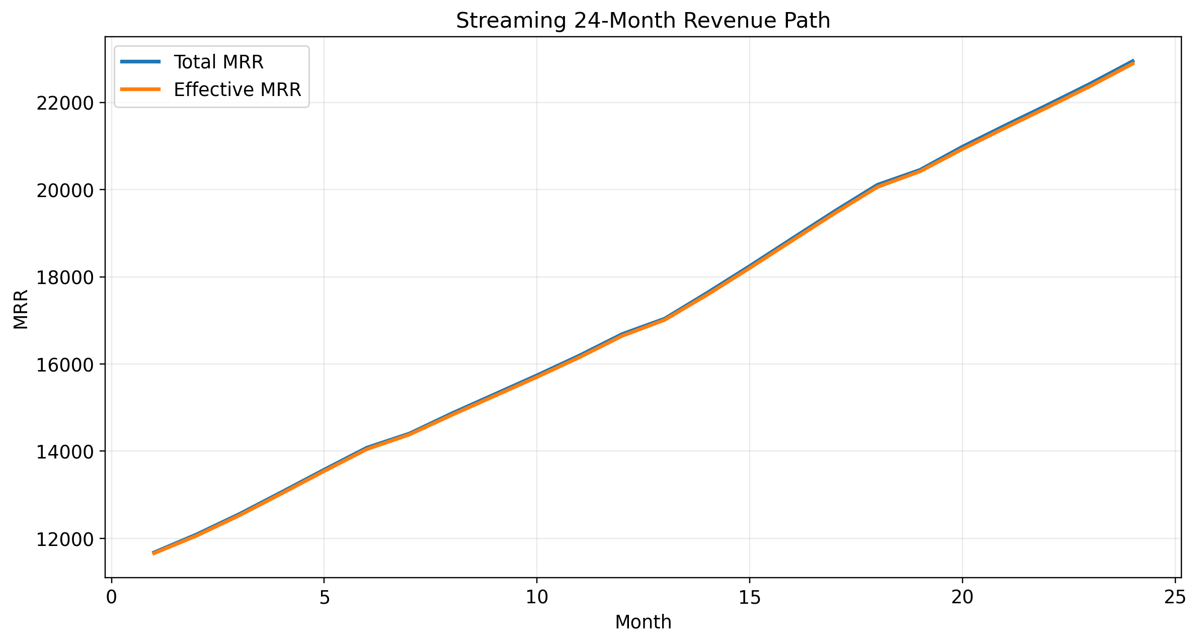
Figure 1. Streaming total MRR and effective MRR across the 24-month horizon.
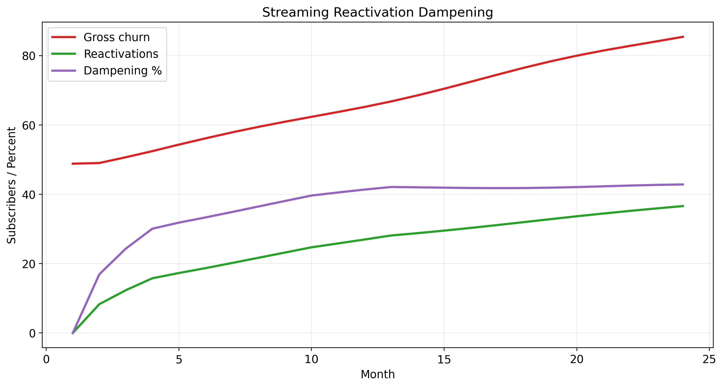
Figure 2. Streaming reactivation dampening of churn across time.
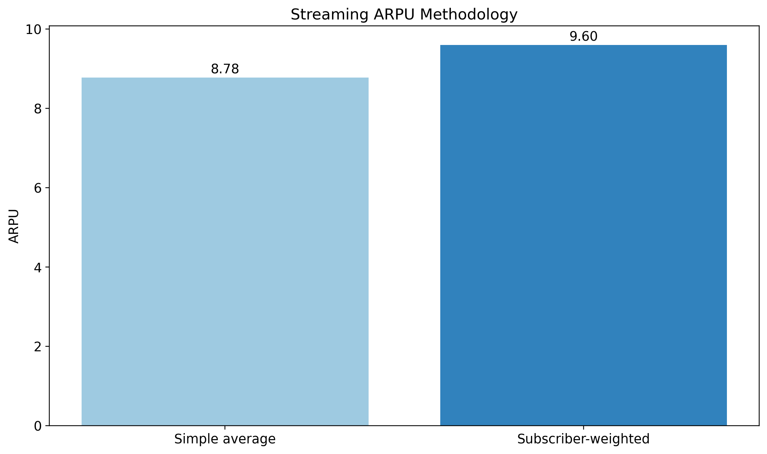
Figure 3. Comparison of simple-average and subscriber-weighted ARPU methodology.

Transparency, Assumptions, Limitations, and Confidence
- The model is benchmark-calibrated from public sources and is not a substitute for first-party event, pricing, and billing data.
- Streaming CAC was excluded because confidence was insufficient; exclusion is preferable to weak output.
- Forecast confidence declines further out in the 24-month horizon, especially after month 12.
- Confidence score 78/100 reflects defensibility and transparency, not a statistical confidence interval.
- Billing leakage, churn, and pricing all have explicit low-base-high scenario ranges because they remain uncertain in public-source-only work.

Appendices
Appendix A: Source list above. Appendix B: Full monthly detail in the Excel workbook. Appendix C: Audit-fix cross references are provided in the updated audit response document. Appendix D: The Data Sources and Assumptions sheets in the workbook provide quick source traceability for executive review.

